**Texturing Practice**

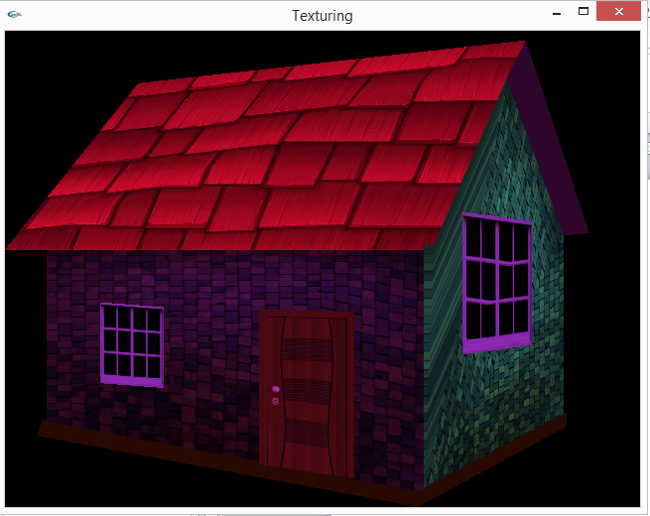

* In this picture, house is designed using different polygons and then texturing is applied to that polygons to give it realistic and 3D effects. All the designing depends on coordinates system to choose coordinates perfectly using photoshop’s grids help.

